As filed with the Securities and Exchange Commission on August 5, 2026
Registration No. 333-
UNITED STATES
SECURITIES AND EXCHANGE COMMISSION
Washington, D.C. 20549
FORM S-8
REGISTRATION STATEMENT
UNDER
THE SECURITIES ACT OF 1933

EXELIXIS, INC.
(Exact name of registrant as specified in its charter)

Delaware |  |  | 04-3257395
(State or other jurisdiction of incorporation or organization) |  |  | (I.R.S. Employer Identification Number)
1851 Harbor Bay Parkway
Alameda, CA 94502
(Address of Principal Executive Offices, including Zip Code)
AMENDED AND RESTATED 2017 EQUITY INCENTIVE PLAN
(Full Title of the Plan)
Michael M. Morrissey
President and Chief Executive Officer
Exelixis, Inc.
1851 Harbor Bay Parkway
Alameda, CA 94502
(650) 837-7000
(Name, Address, and Telephone Number, including Area Code, of Agent for Service)
Copies to:
Brenda J. Hefti |  |  | Raquel Fox
Senior Vice President and General Counsel |  |  | Skadden, Arps, Slate, Meagher & Flom LLP
Exelixis, Inc. |  |  | 1440 New York Ave NW
1851 Harbor Bay Parkway |  |  | Washington, DC 20005
Alameda, CA 94502
Indicate by check mark whether the registrant is a large accelerated filer, an accelerated filer, a non-accelerated filer, a smaller reporting company, or an emerging growth company. See the definitions of “large accelerated filer,” “accelerated filer,” “smaller reporting company,” and “emerging growth company” in Rule 12b-2 of the Exchange Act.
Large accelerated filer |  |  | ☒ |  |  |  |  |  | Accelerated filer |  |  | ☐
Non-accelerated filer |  |  | ☐ |  |  |  |  |  | Smaller reporting company |  |  | ☐
Emerging growth company |  |  | ☐
If an emerging growth company, indicate by check mark if the registrant has elected not to use the extended transition period for complying with any new or revised financial accounting standards provided pursuant to Section 7(a)(2)(B) of the Securities Act. ☐

EXPLANATORY NOTE
This Registration Statement on Form S-8 is being filed by Exelixis, Inc. (the “Company”) for the purpose of registering an additional 2,000,000 shares of common stock, par value $0.001 per share (the “Common Stock”) to be issued pursuant to the Amended and Restated 2017 Equity Incentive Plan (the "2017 Plan"). The shares of the Common Stock previously reserved for issuance under the 2017 Plan were registered on the Company's Registration Statements on Form S-8 previously originally filed with the Securities and Exchange Commission (the "Commission") on May 25, 2017 (File No. 333-218236), August 1, 2018 (File No. 333-226493), August 6, 2020 (File No. 333-241667) and August 9, 2022 (File No. 333-266707) (as amended, collectively, the “Prior Registration Statements”).
This Registration Statement on Form S-8 relates to securities of the same class as that to which the Prior Registration Statements relate, and is submitted in accordance with General Instruction E to Form S-8 regarding Registration of Additional Securities. Pursuant to General Instruction E of Form S-8, the contents of the Prior Registration Statements, to the extent relating to the registration of Common Stock issuable under the 2017 Plan, are incorporated herein by reference and made part of this Registration Statement, except as amended hereby.

PART II
INFORMATION REQUIRED IN THE REGISTRATION STATEMENT
ITEM 3. INCORPORATION OF DOCUMENTS BY REFERENCE
The following documents filed by the Company with the Commission are incorporated by reference into this Registration Statement:
•The Company’s Annual Report on Form 10-K for the fiscal year ended January 2, 2026 (the “Form 10-K”), filed on February 10, 2026;
•The Company’s Quarterly Report on Form 10-Q for the fiscal quarter ended April 3, 2026, filed on May 5, 2026;
•The Company's Quarterly Report on Form 10-Q for the fiscal quarter ended July 3, 2026, filed on August 5, 2026;
•The Company’s Current Reports on Form 8-K filed on May 5, 2026 (but not including any Item 2.02 and Exhibit 99.1 of such filing, which were furnished under applicable Commission rules rather than filed), May 29, 2026, and August 5, 2026; and
•The description of the Company’s common stock that is contained in the Company’s Registration Statement on Form 8-A (File No. 000-30235), filed with the Commission on April 6, 2000, pursuant to Section 12 under the Securities Exchange Act of 1934, as amended (the “Exchange Act”), including any amendment or report filed for the purpose of updating such description, including Exhibit 4.2 to the Form 10-K.
All reports and other documents subsequently filed by the Company pursuant to Sections 13(a), 13(c), 14 and 15(d) of the Exchange Act after the date of this Registration Statement and prior to the filing of a post-effective amendment that indicates that all securities offered have been sold or that deregisters all securities then remaining unsold, shall be deemed to be incorporated by reference herein and to be a part of this Registration Statement from the date of the filing of such reports and documents. Notwithstanding the foregoing, unless specifically stated to the contrary, none of the information that the Company discloses under Items 2.02 or 7.01 of any Current Report on Form 8-K that it may from time to time furnish to the Commission will be incorporated by reference into, or otherwise included in, this Registration Statement. Any statement contained in a document incorporated or deemed to be incorporated by reference herein shall be deemed to be modified or superseded for purposes of this Registration Statement to the extent that a statement contained herein, or in any other subsequently filed document that also is or is deemed to be incorporated by reference herein, modifies or supersedes such statement. Any such statement so modified or superseded shall not be deemed, except as so modified or superseded, to constitute a part of this Registration Statement.

3
ITEM 8. EXHIBITS
Exhibit  Number |  |  |  |  |  | Exhibit Description |  |  |  |  |  | Incorporation by Reference |  |  |  |  |  |  |  |  |  |  |  |  |  |  |  |  |  |  |  |  |  |  |  | Filed  Herewith
 |  |  |  |  |  |  |  |  |  |  |  | Form |  |  |  |  |  | File Number |  |  |  |  |  | Exhibit/  Appendix  Reference |  |  |  |  |  | Filing Date
4.1 |  |  |  |  |  | Restated Certificate of Incorporation of Exelixis, Inc. |  |  |  |  |  | 10-Q |  |  |  |  |  | 000-30235 |  |  |  |  |  | 3.1 |  |  |  |  |  | 8/5/2021
4.2 |  |  |  |  |  | Certificate of Change of Registered Agent and/or Registered Office of Exelixis, Inc. |  |  |  |  |  | 10-Q |  |  |  |  |  | 000-30235 |  |  |  |  |  | 3.2 |  |  |  |  |  | 4/30/2024
4.3 |  |  |  |  |  | Amended and Restated Bylaws of Exelixis, Inc. |  |  |  |  |  | 8-K |  |  |  |  |  | 000-30235 |  |  |  |  |  | 3.1 |  |  |  |  |  | 12/20/2023
5.1 |  |  |  |  |  | Opinion of Skadden, Arps, Slate, Meagher & Flom LLP |  |  |  |  |  |  |  |  |  |  |  |  |  |  |  |  |  |  |  |  |  |  |  |  |  |  |  |  |  | X
23.1 |  |  |  |  |  | Consent of independent registered public accounting firm |  |  |  |  |  |  |  |  |  |  |  |  |  |  |  |  |  |  |  |  |  |  |  |  |  |  |  |  |  | X
23.2 |  |  |  |  |  | Consent of Skadden, Arps, Slate, Meagher & Flom LLP (included in Exhibit 5.1) |  |  |  |  |  |  |  |  |  |  |  |  |  |  |  |  |  |  |  |  |  |  |  |  |  |  |  |  |  | X
24.1 |  |  |  |  |  | Power of Attorney (contained on signature page hereto) |  |  |  |  |  |  |  |  |  |  |  |  |  |  |  |  |  |  |  |  |  |  |  |  |  |  |  |  |  | X
99.1 |  |  |  |  |  | Exelixis, Inc. 2017 Equity Incentive Plan |  |  |  |  |  | 8-K |  |  |  |  |  | 000-30235 |  |  |  |  |  | 10.1 |  |  |  |  |  | 5/29/2026
107 |  |  |  |  |  | Filing Fee Table |  |  |  |  |  |  |  |  |  |  |  |  |  |  |  |  |  |  |  |  |  |  |  |  |  |  |  |  |  | X

4
SIGNATURES
Pursuant to the requirements of the Securities Act of 1933, as amended, the registrant certifies that it has reasonable grounds to believe that it meets all of the requirements for filing on Form S-8 and has duly caused this Registration Statement to be signed on its behalf by the undersigned, thereunto duly authorized, in the City of Alameda, State of California, on August 5, 2026.
EXELIXIS, INC.
By: |  |  | /s/ Michael M. Morrissey
 |  |  | Michael M. Morrissey, Ph. D.
 |  |  | President and Chief Executive Officer
POWER OF ATTORNEY
KNOW ALL PERSONS BY THESE PRESENTS, that each person whose signature appears below constitutes and appoints Michael M. Morrissey, Christopher J. Senner and Brenda J. Hefti and each or any one of them, his or her true and lawful attorney-in-fact and agent, with full power of substitution and resubstitution, for him or her and in his or her name, place and stead, in any and all capacities, to sign any and all amendments (including post-effective amendments) to this Registration Statement, and to file the same, with all exhibits thereto, and other documents in connection therewith, with the Securities and Exchange Commission, granting unto said attorneys-in-fact and agents, and each of them, full power and authority to do and perform each and every act and thing requisite and necessary to be done in connection therewith, as fully to all intents and purposes as he or she might or could do in person, hereby ratifying and confirming all that said attorneys-in-fact and agents, or any of them, or their or his or her substitutes or substitute, may lawfully do or cause to be done by virtue hereof.
Pursuant to the requirements of the Securities Act of 1933, as amended, this Registration Statement has been signed by the following persons in the capacities and on the dates indicated.

Signature |  |  |  |  |  | Title |  |  |  |  |  | Date
/s/ MICHAEL M. MORRISSEY |  |  |  |  |  | Director, President and |  |  |  |  |  | August 5, 2026
Michael M. Morrissey, Ph.D. |  |  |  |  |  | Chief Executive Officer (Principal Executive Officer)
/s/ CHRISTOPHER J. SENNER |  |  |  |  |  | Executive Vice President and |  |  |  |  |  | August 5, 2026
Christopher J. Senner |  |  |  |  |  | Chief Financial Officer  (Principal Financial and Accounting Officer)
/s/ STELIOS PAPADOPOULOS |  |  |  |  |  | Chairman of the Board |  |  |  |  |  | August 5, 2026
Stelios Papadopoulos, Ph.D.
/s/ MARY C. BECKERLE |  |  |  |  |  | Director |  |  |  |  |  | August 5, 2026
Mary C. Beckerle, Ph.D.
/s/ S. GAIL ECKHARDT |  |  |  |  |  | Director |  |  |  |  |  | August 5, 2026
S. Gail Eckhardt, M.D.
/s/ MARIA C. FREIRE |  |  |  |  |  | Director |  |  |  |  |  | August 5, 2026
Maria C. Freire, Ph.D.
5
Signature |  |  |  |  |  | Title |  |  |  |  |  | Date
/s/ TOMAS J. HEYMAN |  |  |  |  |  | Director |  |  |  |  |  | August 5, 2026
Tomas J. Heyman
/s/ DAVID E. JOHNSON |  |  |  |  |  | Director |  |  |  |  |  | August 5, 2026
David E. Johnson
/s/ ROBERT L. OLIVER |  |  |  |  |  | Director |  |  |  |  |  | August 5, 2026
Robert L. Oliver, Jr.
/s/ GEORGE POSTE |  |  |  |  |  | Director |  |  |  |  |  | August 5, 2026
George Poste, DVM, Ph.D., FRS
/s/ JULIE A. SMITH |  |  |  |  |  | Director |  |  |  |  |  | August 5, 2026
Julie A. Smith
/s/ JACK L. WYSZOMIERSKI |  |  |  |  |  | Director |  |  |  |  |  | August 5, 2026
Jack L. Wyszomierski

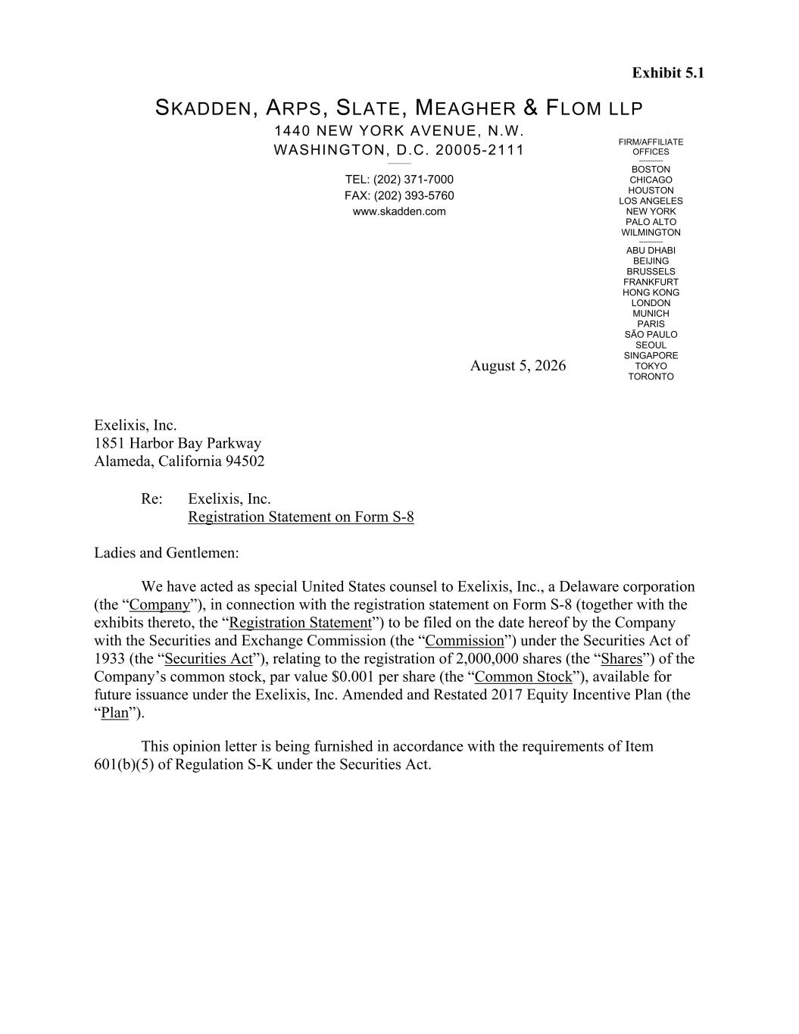
6
Exhibit 5.1 FIRM/AFFILIATE OFFICES ----------- BOSTON CHICAGO HOUSTON LOS ANGELES NEW YORK PALO ALTO WILMINGTON ----------- ABU DHABI BEIJING BRUSSELS FRANKFURT HONG KONG LONDON MUNICH PARIS SÃO PAULO SEOUL SINGAPORE TOKYO TORONTO SKADDEN, ARPS, SLATE, MEAGHER & FLOM LLP 1440 NEW YORK AVENUE, N.W. WASHINGTON, D.C. 20005-2111 ________ TEL: (202) 371-7000 FAX: (202) 393-5760 www.skadden.com August 5, 2026 Exelixis, Inc. 1851 Harbor Bay Parkway Alameda, California 94502 Re: Exelixis, Inc. Registration Statement on Form S-8 Ladies and Gentlemen: We have acted as special United States counsel to Exelixis, Inc., a Delaware corporation (the “Company”), in connection with the registration statement on Form S-8 (together with the exhibits thereto, the “Registration Statement”) to be filed on the date hereof by the Company with the Securities and Exchange Commission (the “Commission”) under the Securities Act of 1933 (the “Securities Act”), relating to the registration of 2,000,000 shares (the “Shares”) of the Company’s common stock, par value $0.001 per share (the “Common Stock”), available for future issuance under the Exelixis, Inc. Amended and Restated 2017 Equity Incentive Plan (the “Plan”). This opinion letter is being furnished in accordance with the requirements of Item 601(b)(5) of Regulation S-K under the Securities Act.

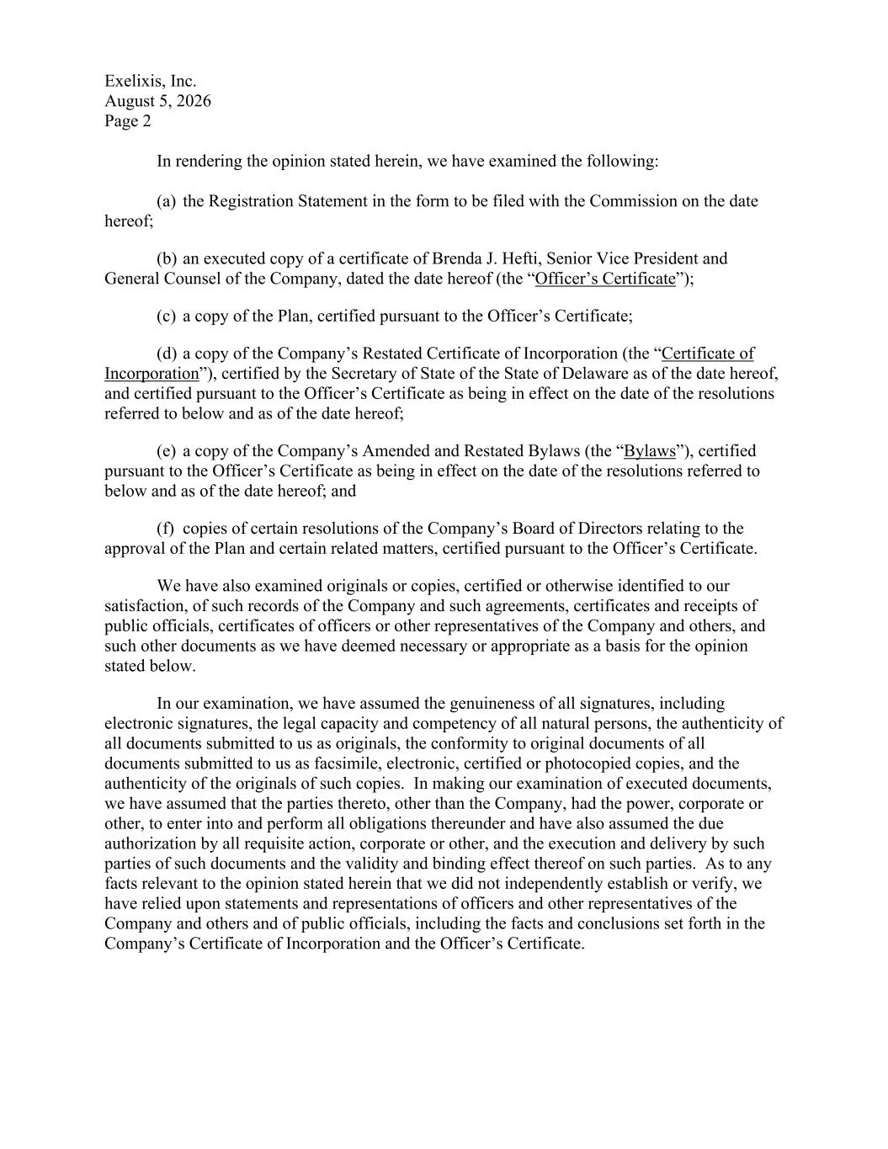
Exelixis, Inc. August 5, 2026 Page 2 In rendering the opinion stated herein, we have examined the following: (a) the Registration Statement in the form to be filed with the Commission on the date hereof; (b) an executed copy of a certificate of Brenda J. Hefti, Senior Vice President and General Counsel of the Company, dated the date hereof (the “Officer’s Certificate”); (c) a copy of the Plan, certified pursuant to the Officer’s Certificate; (d) a copy of the Company’s Restated Certificate of Incorporation (the “Certificate of Incorporation”), certified by the Secretary of State of the State of Delaware as of the date hereof, and certified pursuant to the Officer’s Certificate as being in effect on the date of the resolutions referred to below and as of the date hereof; (e) a copy of the Company’s Amended and Restated Bylaws (the “Bylaws”), certified pursuant to the Officer’s Certificate as being in effect on the date of the resolutions referred to below and as of the date hereof; and (f) copies of certain resolutions of the Company’s Board of Directors relating to the approval of the Plan and certain related matters, certified pursuant to the Officer’s Certificate. We have also examined originals or copies, certified or otherwise identified to our satisfaction, of such records of the Company and such agreements, certificates and receipts of public officials, certificates of officers or other representatives of the Company and others, and such other documents as we have deemed necessary or appropriate as a basis for the opinion stated below. In our examination, we have assumed the genuineness of all signatures, including electronic signatures, the legal capacity and competency of all natural persons, the authenticity of all documents submitted to us as originals, the conformity to original documents of all documents submitted to us as facsimile, electronic, certified or photocopied copies, and the authenticity of the originals of such copies. In making our examination of executed documents, we have assumed that the parties thereto, other than the Company, had the power, corporate or other, to enter into and perform all obligations thereunder and have also assumed the due authorization by all requisite action, corporate or other, and the execution and delivery by such parties of such documents and the validity and binding effect thereof on such parties. As to any facts relevant to the opinion stated herein that we did not independently establish or verify, we have relied upon statements and representations of officers and other representatives of the Company and others and of public officials, including the facts and conclusions set forth in the Company’s Certificate of Incorporation and the Officer’s Certificate.

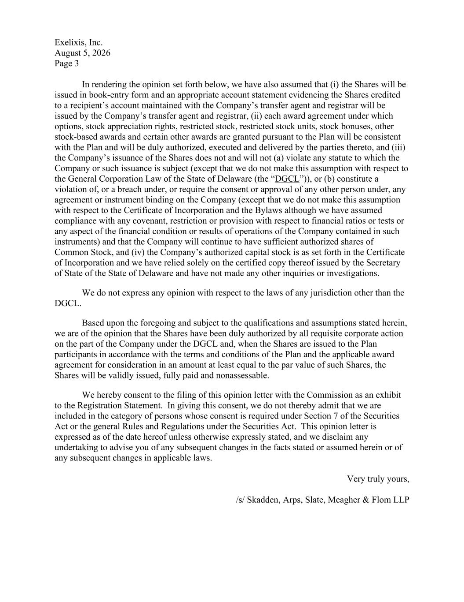
Exelixis, Inc. August 5, 2026 Page 3 In rendering the opinion set forth below, we have also assumed that (i) the Shares will be issued in book-entry form and an appropriate account statement evidencing the Shares credited to a recipient’s account maintained with the Company’s transfer agent and registrar will be issued by the Company’s transfer agent and registrar, (ii) each award agreement under which options, stock appreciation rights, restricted stock, restricted stock units, stock bonuses, other stock-based awards and certain other awards are granted pursuant to the Plan will be consistent with the Plan and will be duly authorized, executed and delivered by the parties thereto, and (iii) the Company’s issuance of the Shares does not and will not (a) violate any statute to which the Company or such issuance is subject (except that we do not make this assumption with respect to the General Corporation Law of the State of Delaware (the “DGCL”)), or (b) constitute a violation of, or a breach under, or require the consent or approval of any other person under, any agreement or instrument binding on the Company (except that we do not make this assumption with respect to the Certificate of Incorporation and the Bylaws although we have assumed compliance with any covenant, restriction or provision with respect to financial ratios or tests or any aspect of the financial condition or results of operations of the Company contained in such instruments) and that the Company will continue to have sufficient authorized shares of Common Stock, and (iv) the Company’s authorized capital stock is as set forth in the Certificate of Incorporation and we have relied solely on the certified copy thereof issued by the Secretary of State of the State of Delaware and have not made any other inquiries or investigations. We do not express any opinion with respect to the laws of any jurisdiction other than the DGCL. Based upon the foregoing and subject to the qualifications and assumptions stated herein, we are of the opinion that the Shares have been duly authorized by all requisite corporate action on the part of the Company under the DGCL and, when the Shares are issued to the Plan participants in accordance with the terms and conditions of the Plan and the applicable award agreement for consideration in an amount at least equal to the par value of such Shares, the Shares will be validly issued, fully paid and nonassessable. We hereby consent to the filing of this opinion letter with the Commission as an exhibit to the Registration Statement. In giving this consent, we do not thereby admit that we are included in the category of persons whose consent is required under Section 7 of the Securities Act or the general Rules and Regulations under the Securities Act. This opinion letter is expressed as of the date hereof unless otherwise expressly stated, and we disclaim any undertaking to advise you of any subsequent changes in the facts stated or assumed herein or of any subsequent changes in applicable laws. Very truly yours, /s/ Skadden, Arps, Slate, Meagher & Flom LLP

Exhibit 23.1
CONSENT OF INDEPENDENT REGISTERED PUBLIC ACCOUNTING FIRM
We consent to the incorporation by reference in the Registration Statement (Form S-8) pertaining to the Amended and Restated 2017 Equity Incentive Plan of Exelixis, Inc. of our reports dated February 10, 2026, with respect to the consolidated financial statements of Exelixis Inc. and the effectiveness of internal control over financial reporting of Exelixis Inc. included in its Annual Report (Form 10-K) for the year ended January 2, 2026, filed with the Securities and Exchange Commission.

San Mateo, California
August 5, 2026

Exhibit 107

CALCULATION OF REGISTRATION FEE

Security Type |  |  | Title of Securities  to be Registered |  |  | Fee Calculation Rule |  |  | Amount Being  Registered (1) |  |  | Proposed Maximum  Offering  Price per Unit |  |  | Proposed Maximum Aggregate  Offering Price |  |  | Fee Rate |  |  | Amount of  Registration Fee
Equity |  |  | Common Stock, $0.001 par value per share |  |  | Rule 457(c) and (h) |  |  | 2,000,000 |  |  | $55.360(2) |  |  | $110,720,000(2) |  |  | 0.00013810 |  |  | $15,290
Total Offering Amounts |  |  |  |  |  |  |  |  |  |  |  |  |  |  | $110,720,000 |  |  |  |  |  | $15,290
Total Fees Previously Paid |  |  |  |  |  |  |  |  |  |  |  |  |  |  |  |  |  |  |  |  | $0
Total Fee Offsets |  |  |  |  |  |  |  |  |  |  |  |  |  |  |  |  |  |  |  |  | $0
Net Fee Due |  |  |  |  |  |  |  |  |  |  |  |  |  |  |  |  |  |  |  |  | $15,290
(1) This Registration Statement covers the offer and sale of 2,000,000 shares of Common Stock of Exelixis, Inc. (the “Registrant” or the “Company”) under the Exelixis, Inc. Amended and Restated 2017 Equity Incentive Plan (the “Plan”). Pursuant to Rule 416(a) of the Securities Act of 1933, as amended (the “Securities Act”), this Registration Statement shall also cover any additional shares of the Registrant’s Common Stock that become issuable under the Plan by reason of any stock dividend, stock split, recapitalization or other similar transaction effected without receipt of consideration that increases the number of outstanding shares of the Registrant’s Common Stock.
(2) Estimated solely for the purpose of calculating the amount of the registration fee pursuant to Rule 457(h) under the Securities Act. The offering price per share and aggregate offering price are based upon the average of the high and low prices of the Registrant’s Common Stock on July 30, 2026, as reported on the Nasdaq Global Select Market.

